Maleeha Ali

**Test Cases And Results**

After running through our test cases to ensure that all of our system correctly works, we have recorded our outputs and our attempts to show the company what the software looks like and how it reacts to certain inputs.

For the login screen, we tested an incorrect username and password to ensure the security of the system:

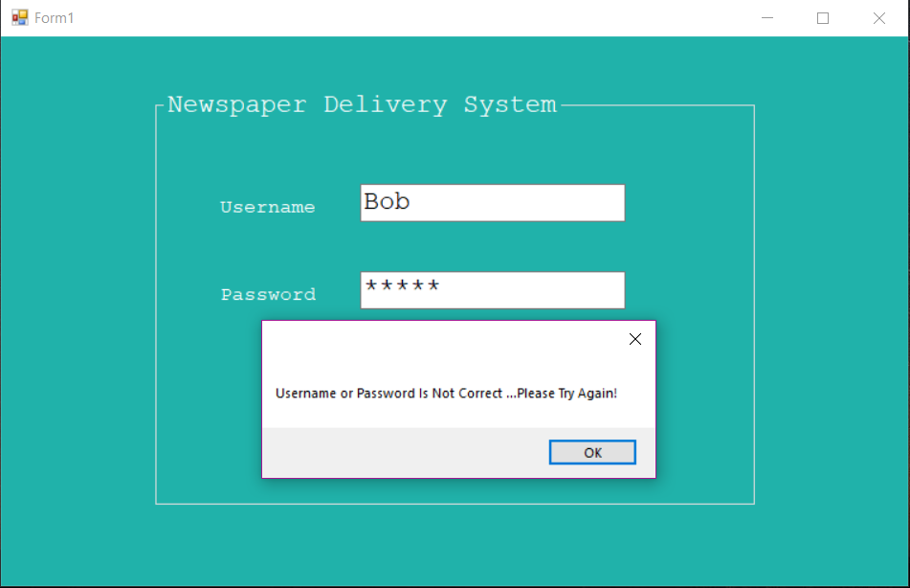

After testing that the program doesn’t allow any random user, we then inputted the correct information:

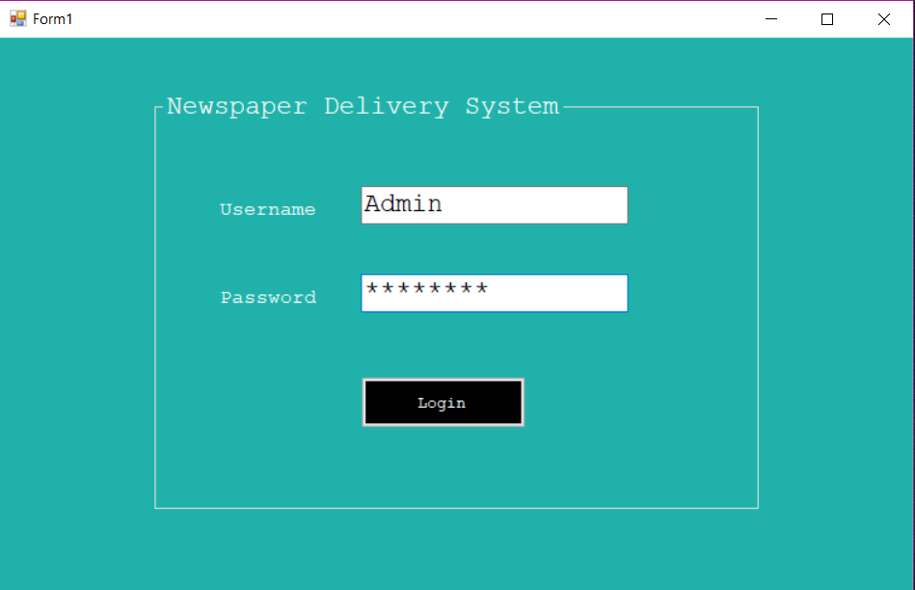

Once we input the correct information, the menu pops up. For the main menu, we offered different options based on what the company wanted the system to do:

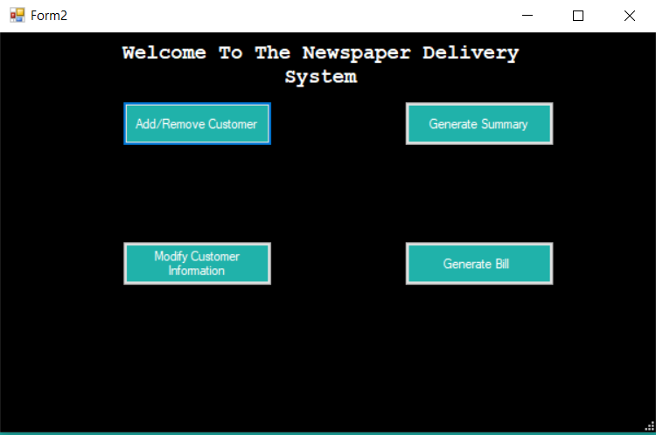

After hitting the add/remove customer button, this form pops up:

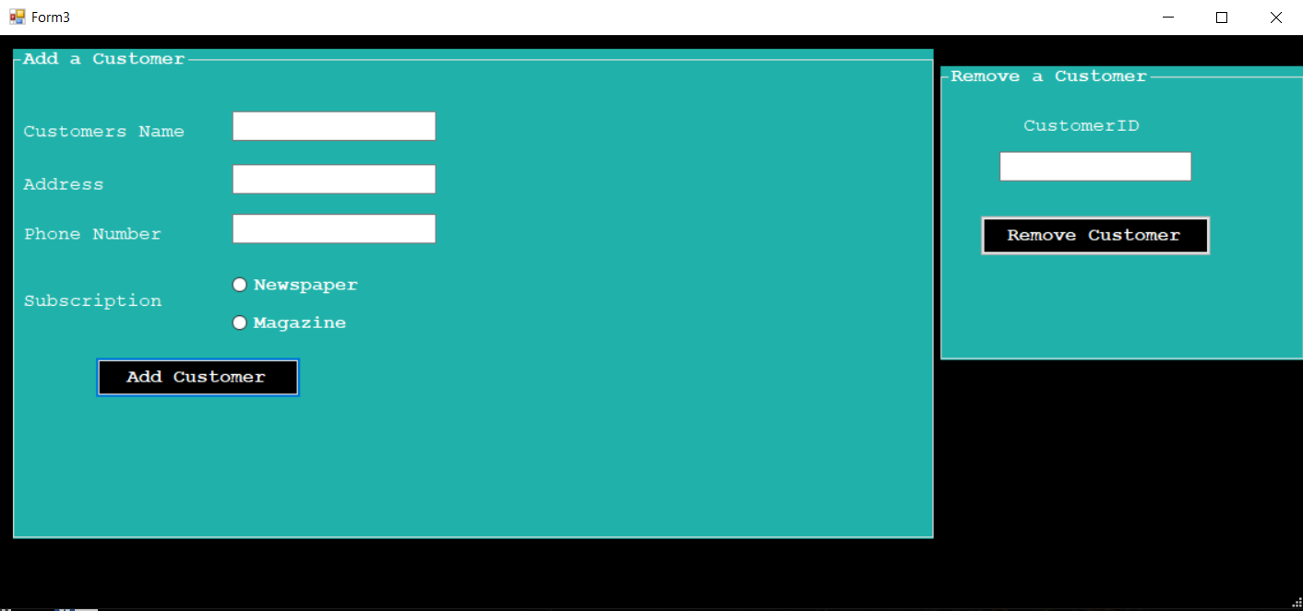

After inserting information to the add a customer section, another section will pop up for carrier information:

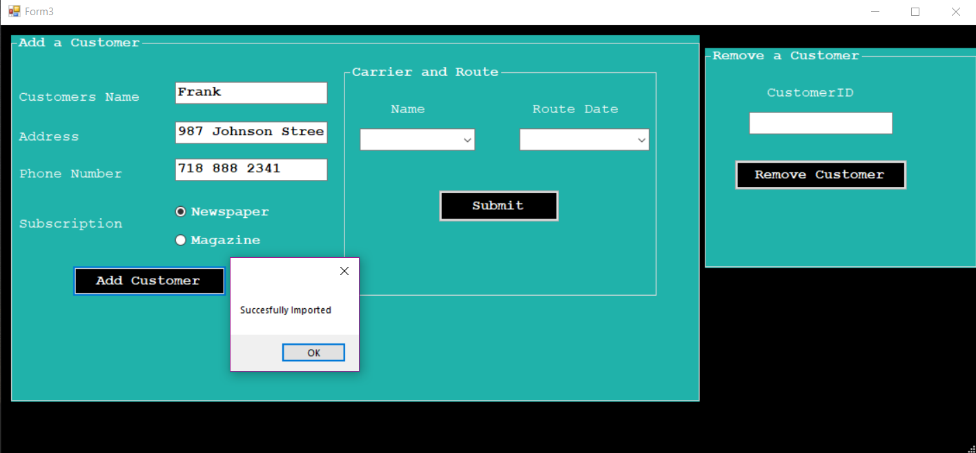

After that, the employee will fill in those fields and hit submit and a message box will appear:

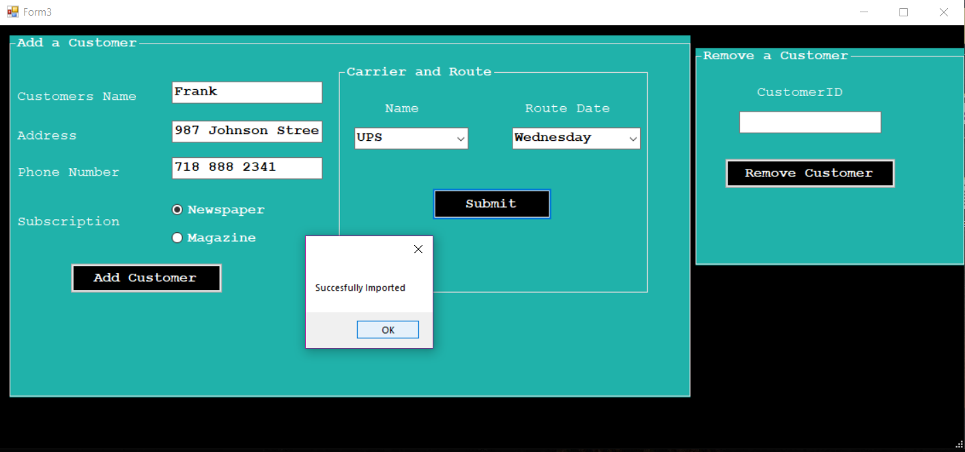

If any of these fields is left empty, an error will appear:

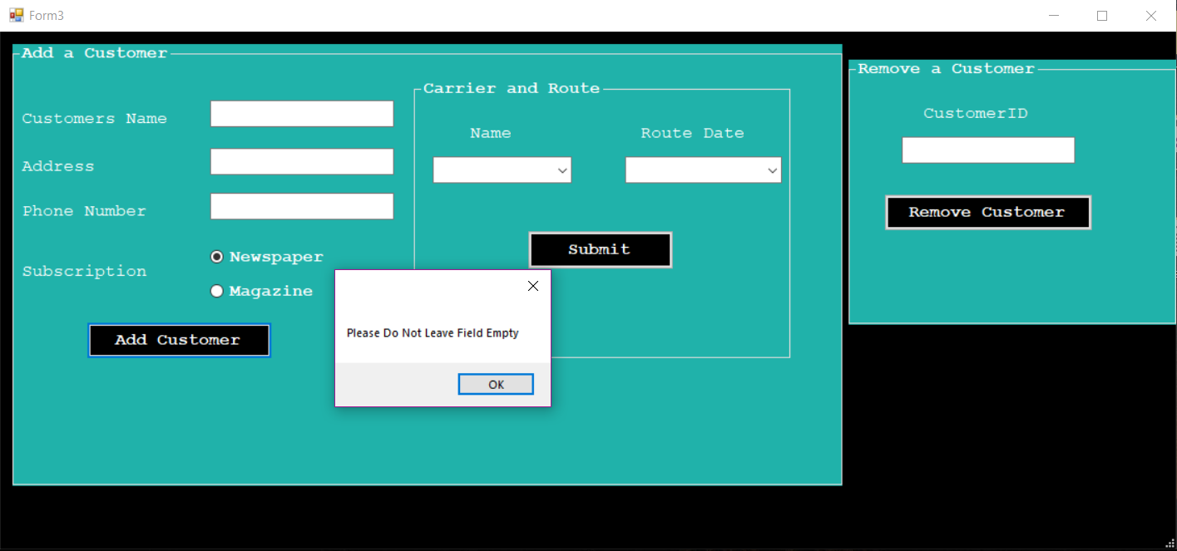

To remove a customer, the employee will enter the customer ID and hit remove customer and a message box will appear:

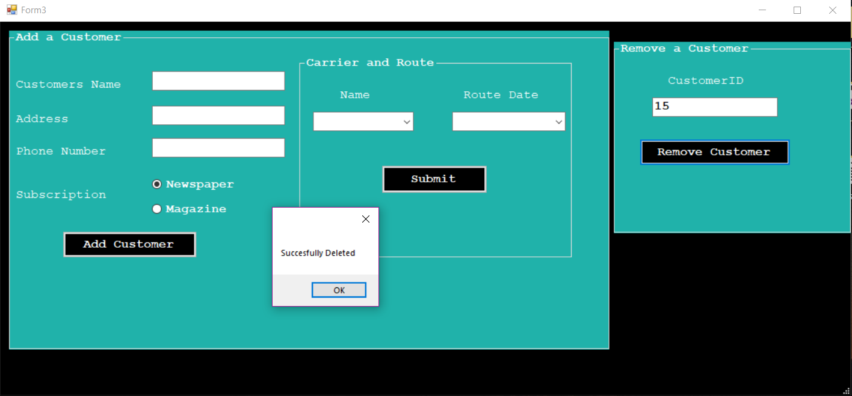

After checking all of the aspects of the remove/add customer form, we move on to the modify customer information form where the employee can change any information for the customer and even place a hold:

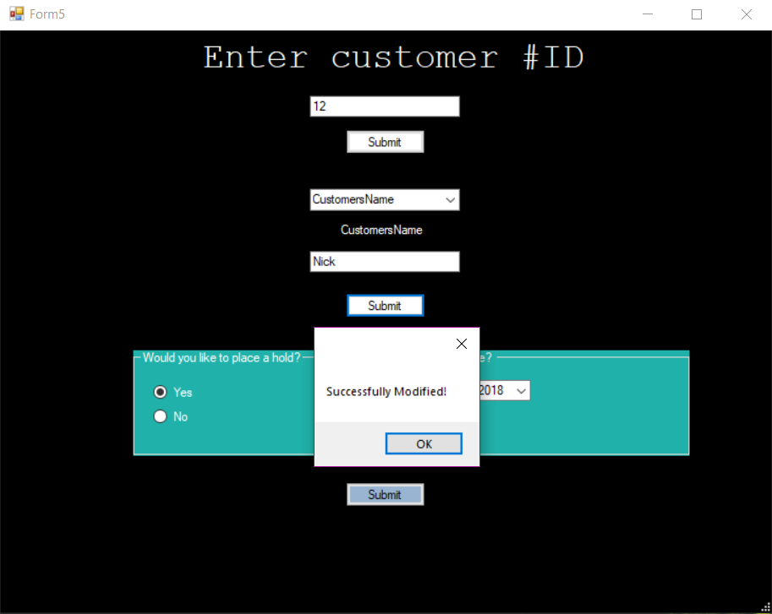

There are two seperate buttons and each button pops up a message box to let the employee that the information was successfully changed

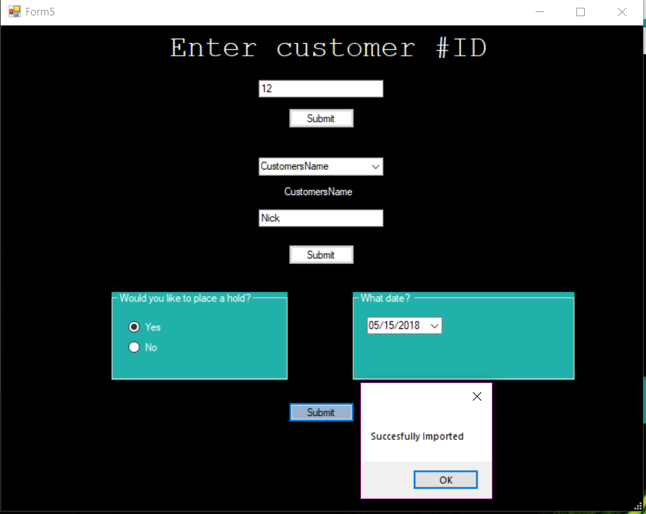

After checking the modify information form, we move onto the generating the summary bills where executives of companies will know how much money they are making:

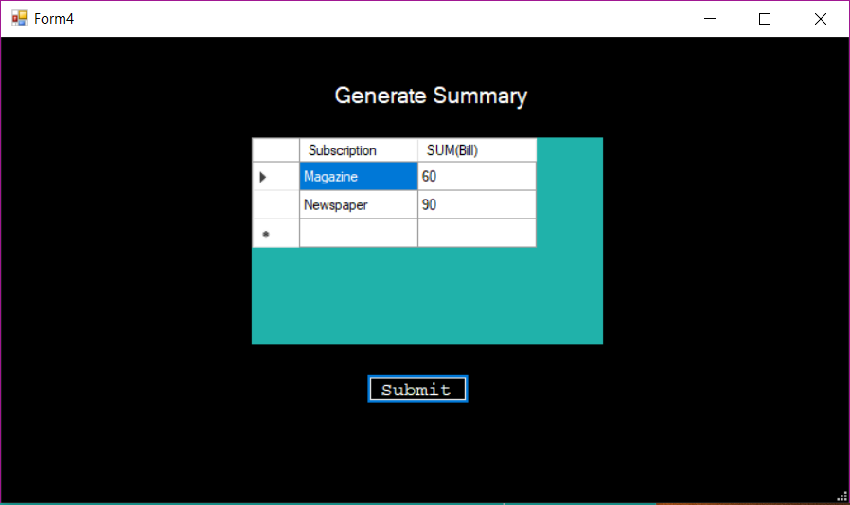

After that, we check the generate bill form. This form takes the customer ID and generates their bill information:

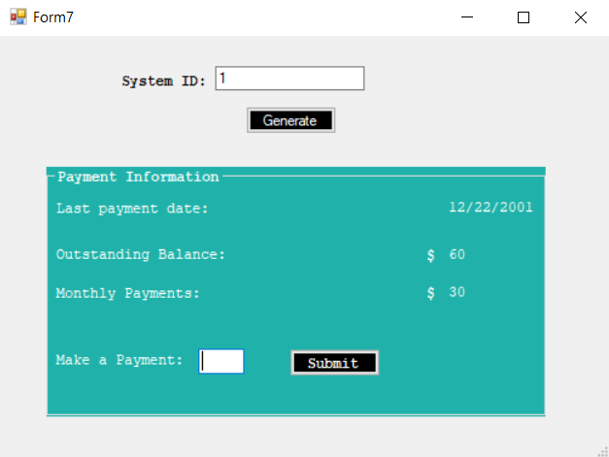

They employee is also able to make a payment for the customer on this form:

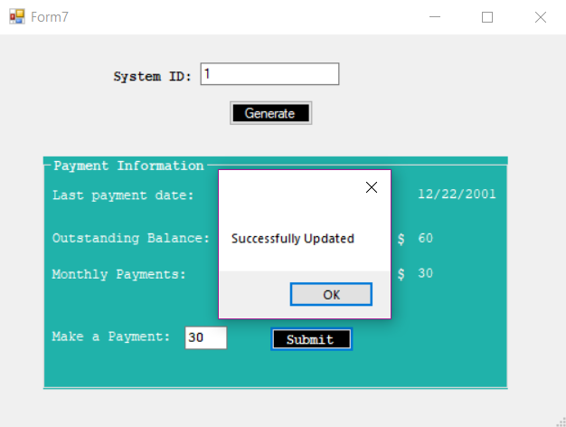

Once they customer makes a payment, the bill is updated:

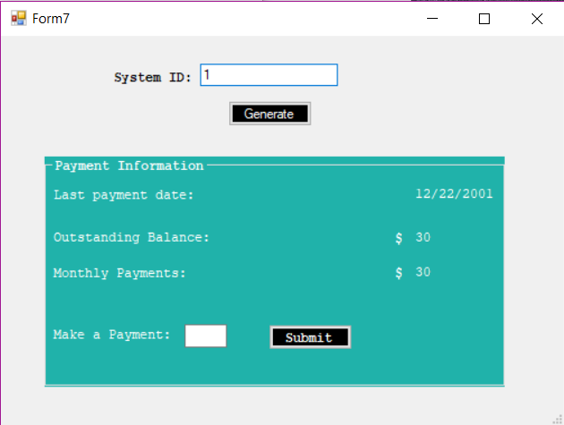

The screenshots below display what the database looks like:

